Nftables Status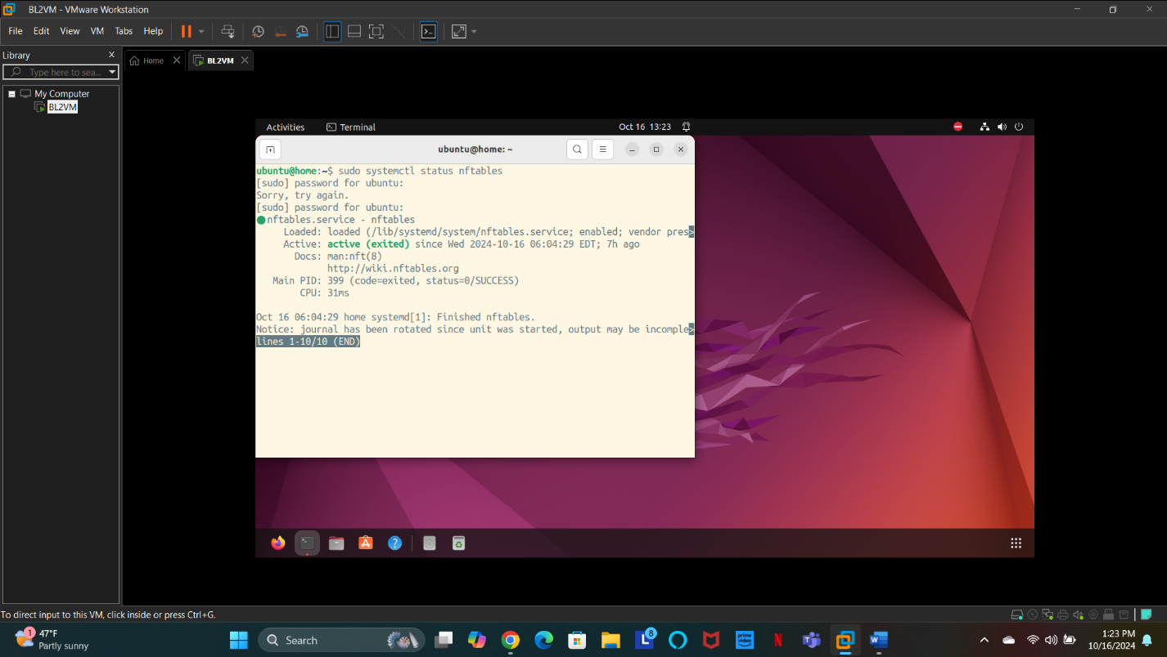

Figure - nftables_status

Firewall Setup

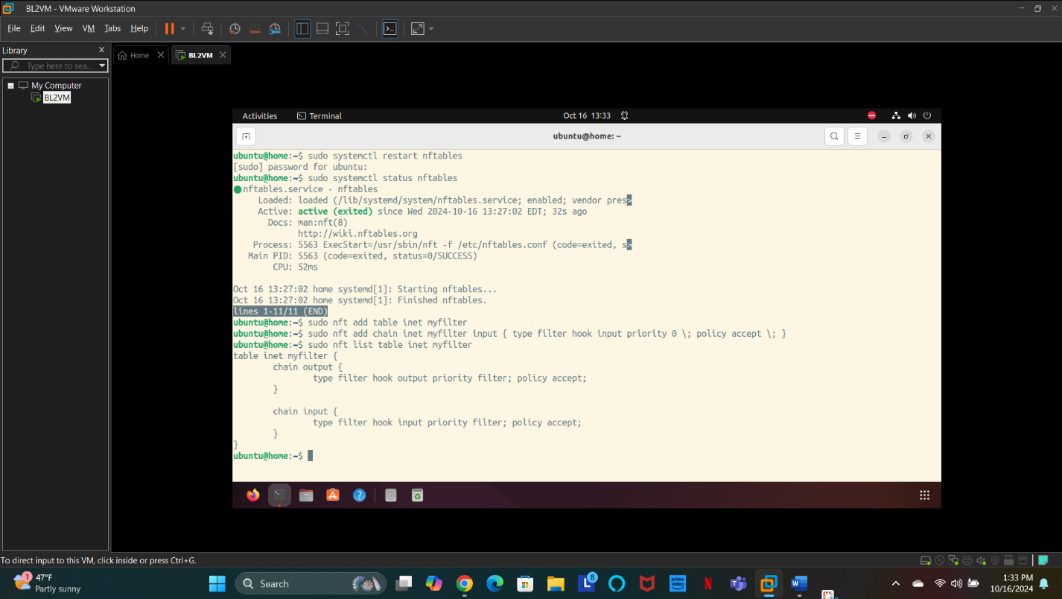

Figure - inet_table

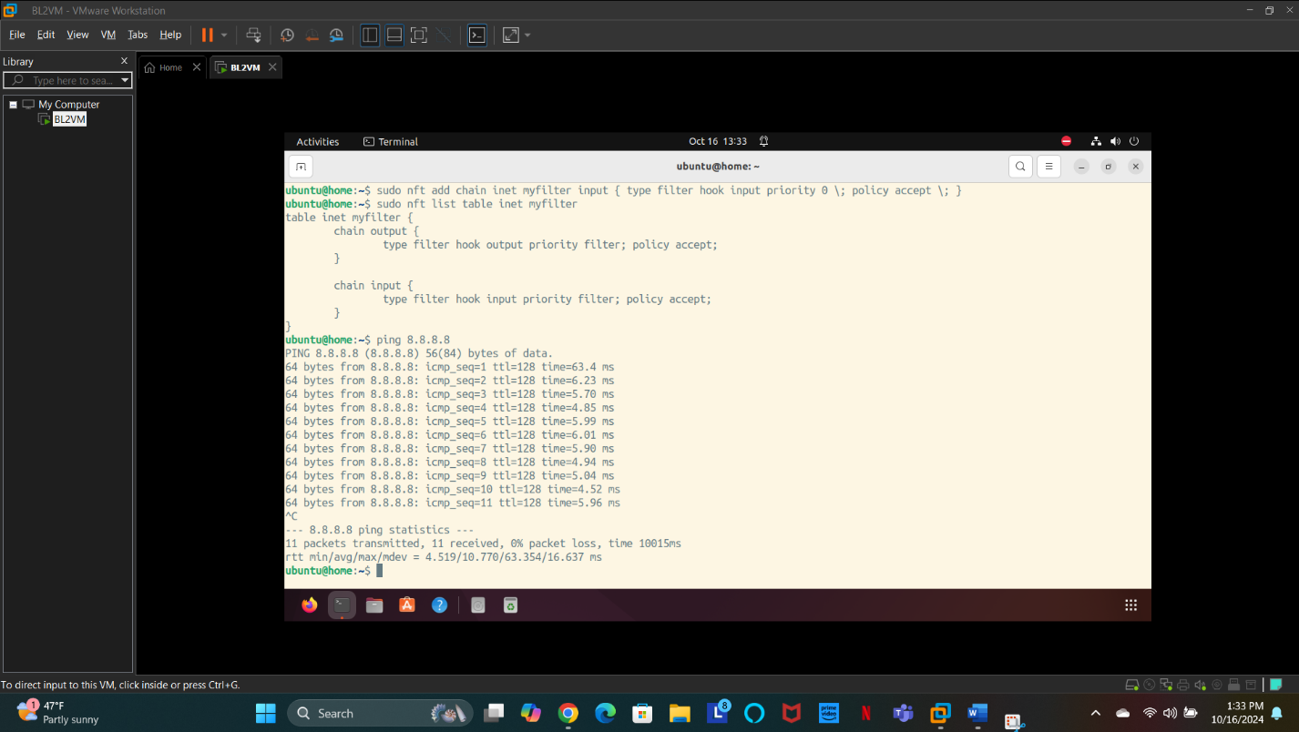

Figure - PingTest

Firewall Filtering

Loaded Website

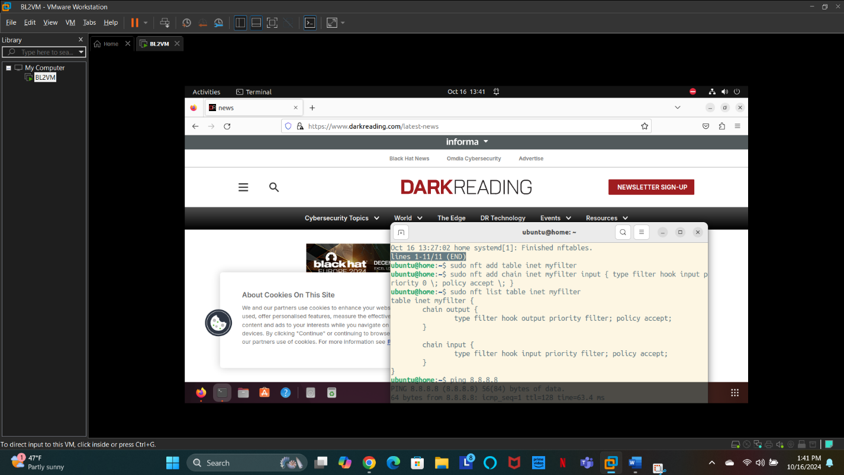

Figure – LoadedPage

Firewall Rule Added – Web Blocking

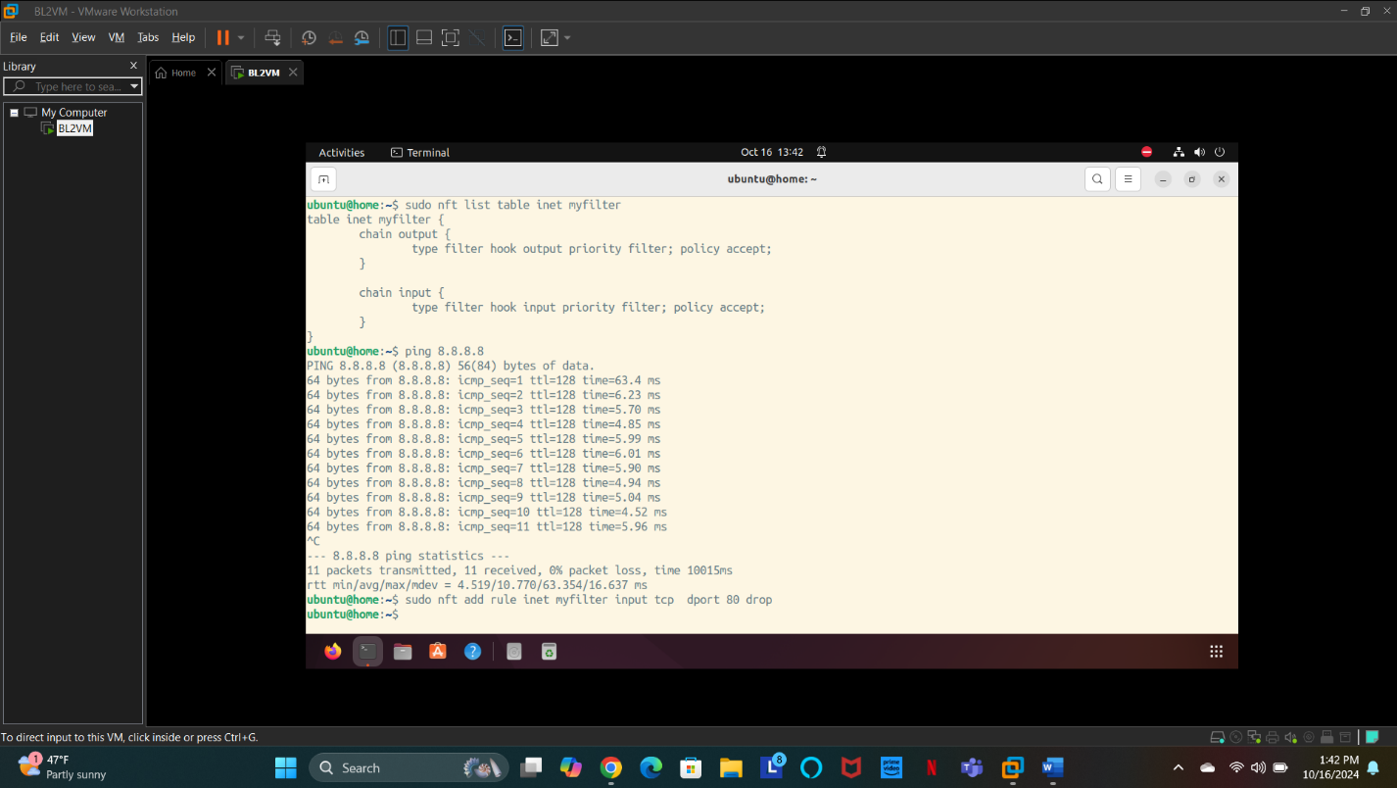

Figure – FirewallRuleAdded

Web Traffic Blocked

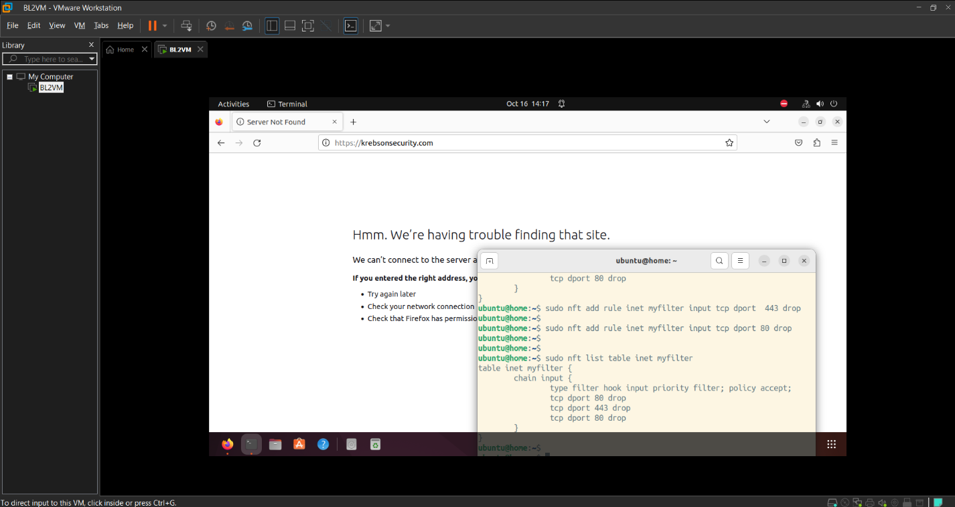

Figure – WebTrafficBlocked

Successful Ping

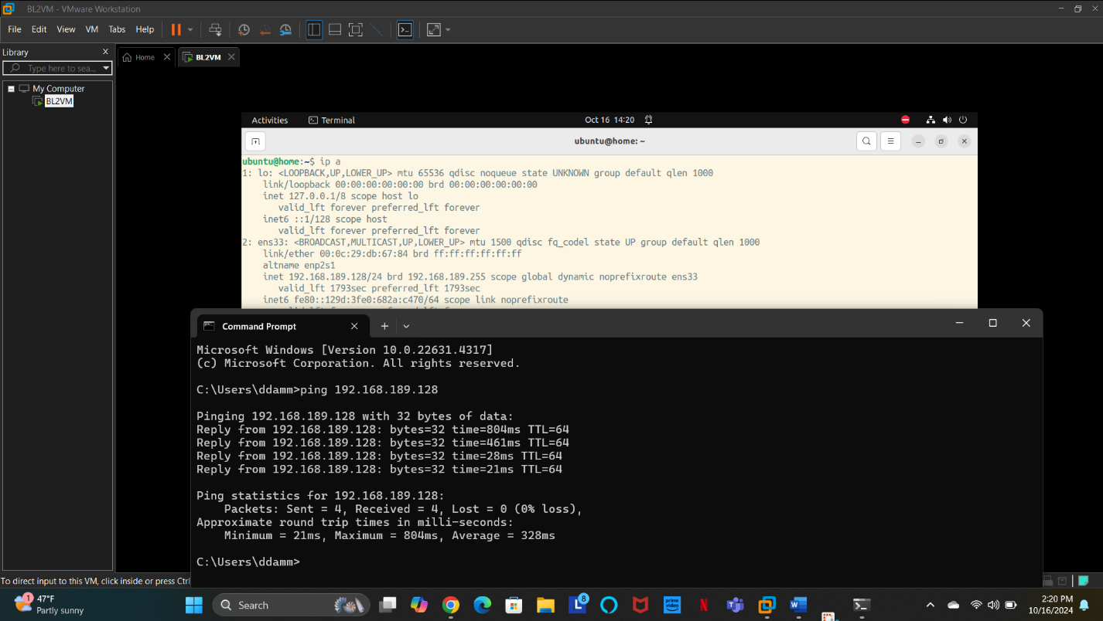

Figure – SuccessfulPing

Unsuccessful Ping

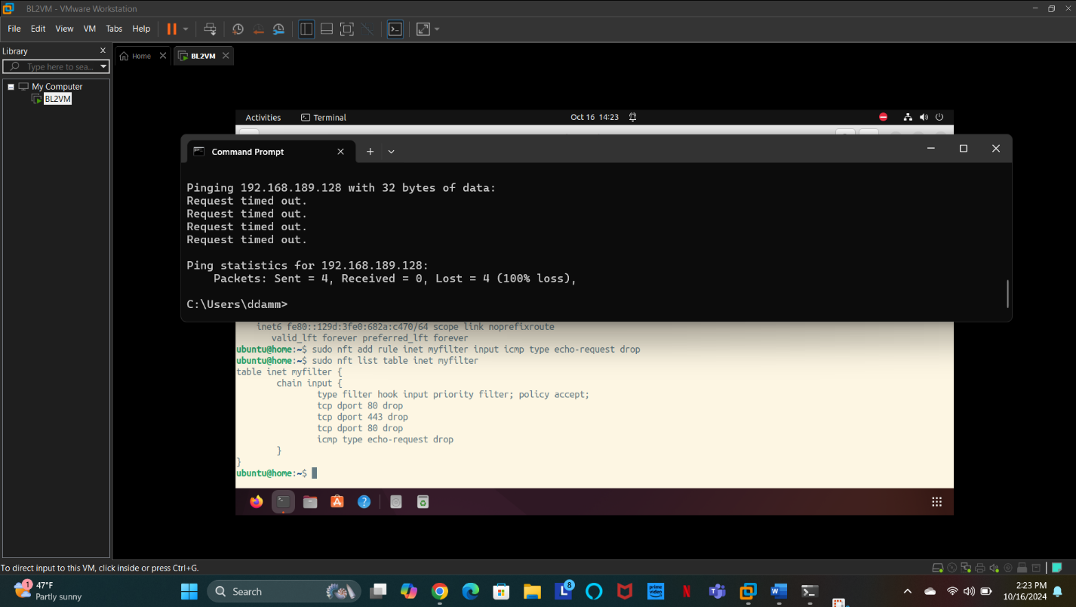

Figure - UnsuccessfulPing